Laravel based Job Portal Web App

By
Suleman Imran
S25BINFT7M04036
Session Spring 2025 – 2027
ADP-7th 1M

Supervisor
Mr. Omer Riaz

Department of Information Technology

Faculty of Computing

The Islamia University Of Bahawalpur

Meeting Details

Sr No | Details | Date | Supervisor Signature

Table of Contents

- Introduction 4
  - Purpose 4
  - Scope 5
  - Product perspective 6
  - User characteristics 6
  - Similar apps and system 7
  - Proposed technologies 8

- Requirements 8
  - Function Requirement 8
  - Non-functional requirement 10

- Use case diagram 11
  - Use case 11
  - Activity diagram 26

- Reference 32

SUMMARY

A job portal is an online platform designed to connect job seekers with employers by offering a centralized space for job listings and applications. It simplifies the recruitment process through features like resume uploads, job search filters, automated job alerts, application tracking, and company profiles. For employers, it provides tools to post vacancies, screen candidates, and manage recruitment efficiently. For job seekers, it offers access to diverse employment opportunities, personalized job recommendations, and career development resources.

The purpose of a job portal is to bridge the gap between employers and candidates, making the hiring process more efficient, accessible, and strategic.

The scope of a job portal includes:

1. Broad job listing access across industries.
2. Easy resume upload and management.
3. Automated job alerts tailored to user preferences.
4. Application tracking systems.
5. Insightful company profiles.
6. Networking features to connect with professionals.

Overall, job portals play a vital role in the modern job market by digitizing and optimizing the job search and hiring

1. Introduction
A job portal is an online platform that connects job seekers with employers by providing a centralized space where job opportunities are posted and applications can be submitted. These portals streamline the recruitment process by offering features such as resume uploads, job search filters, company profiles, and automated job alerts. For employers, job portals offer tools to post vacancies, review applications, and find suitable candidates based on specific criteria. For job seekers, they provide access to a wide range of employment opportunities across various industries and locations, often including resources for career development and interview preparation.
Many portals offer personalized job recommendations based on user profiles and preferences. They save time and effort for both employers and applicants by digitizing and automating many hiring steps. Overall, job portals play a crucial role in today's job market by making the job search and recruitment process more efficient and accessible.
Moreover, recognizing the holistic needs of job seekers, many platforms also integrate supplementary resources aimed at fostering career development and enhancing interview preparedness, ultimately transforming the job search from a potentially daunting task into a more informed and strategic endeavor.

1.1 Purpose
A job portal is an online platform that connects job seekers with employers by providing a centralized space where job opportunities are posted and applications can be submitted. These portals streamline the recruitment process by offering features such as resume uploads, job search filters, company profiles, and automated job alerts. For employers, job portals offer tools to post vacancies, review applications, and find suitable candidates based on specific criteria. For job seekers, they provide access to a wide range of employment opportunities across various industries and locations, often including resources for career development and interview preparation.
Additionally, many portals offer personalized job recommendations based on user profiles and preferences. They save time and effort for both employers and applicants by digitizing and automating many hiring steps. Overall, job portals play a crucial role in today's job market by making the job search and recruitment process more efficient and accessible. The main purpose of a job portal is to bridge the gap between job seekers and employers, providing a convenient and effective platform that enhances visibility, simplifies hiring, and helps individuals find the right career opportunities.
Advantages of a job portal include:
- 24/7 accessibility: users can search and apply for jobs anytime, from anywhere
- Wide range of opportunities: thousands of jobs from sectors are available.
- Cost-effective: companies hiring for employers without expensive advertising.
- Efficient filtering tools: Advanced filters help users find ideal jobs.
- Career resources: many portals provide resume tips, interview guidance, and skill

1.2 Scope
The scope of a job portal includes connecting job seekers with employers by offering job listings, resume uploads, and application tracking. It provides advanced search tools for job matching and offers resources for career development. Additionally, job portals streamline the recruitment process, benefiting both companies and job seekers globally.
The scope includes the ability to post job vacancies, review applicants, and manage recruitment processes efficiently. Job portals often offer tools for candidate screening, tracking applications, and promoting job listings to a larger pool of potential candidates.
- Job Listing Access: Provides a wide range of job opportunities across various industries and locations.
- Resume Upload: Enables job seekers to upload and update resumes for easy applications.
- Job Alerts: Sends automated notifications for new job openings matching user profiles.
- Application Tracking: Enables users to track the status of their job applications.
- Company Profiles: Allows job seekers to learn more about employers, their culture, and values.
- Networking Opportunities: Facilitates connections between job seekers and industry professionals through the platform.

Key Features of a Job Portal:
- User-friendly Interface: Easy navigation for both job seekers and employers.
- Personalized Job Recommendations: Based on user profiles, preferences, and past searches.
- Real-time Notifications: Alerts about new job postings, application status, and recruitment events.
- Secure Profile Management: Protects user data with encryption and privacy settings.
- Mobile Compatibility: Access to job search and application features via mobile apps.

1.3 Target Audience
- University Students and Recent Graduates – Seeking internships, entry-level jobs, and volunteer opportunities.
- Employers – University departments, alumni networks, local businesses looking to hire students or recent graduates.
- University Administrators (Optional) –To oversee the platform and potentially track placement statistics.

1.4 Product Perspective
The basic university job portal will be a standalone web application. It will not directly integrate with other university systems initially, but future integration (e.g., with student information systems for pre-filling profile data) could be considered.

Product Functions
The system will provide the following core functionalities:
- User Management:
- Student/Graduate Registration and Login.
- Employer Registration and Login.
- Profile Creation and Management (for both students/graduates and employers).
- Job/Opportunity Management:
- Employers posting new job/internship/volunteer opportunities.
- Students/graduates searching and viewing job/internship/volunteer opportunities.
- Students/graduates applying for opportunities.
- Application Management:
- Employers viewing and managing applications received.

1.5 User Characteristics
- Job Seekers
People using the platform to search for employment.
Characteristics:
- Goals: Find jobs, apply quickly, track applications, get noticed by employers.
- Behavior:
      - Regularly searches for new job listings.
      - Uploads resumes and fills out profile information.
      - Uses filters (e.g., location, salary, experience level).
      - May save jobs or set alerts.
- Pain Points: Complex application processes, lack of feedback, poor job matches.
- Employers / Recruiters
Companies or hiring managers posting jobs and looking for candidates.

Characteristics:
- Goals: Find suitable candidates efficiently, promote employer brand.
- Behavior:
    - Posts job openings and manages listings.
    - Searches candidate database.
    - Reviews applications, schedules interviews.
- Pain Points: Too many unqualified applicants, low visibility of job posts, lack of filtering tools.
- Administrators
Internal platform managers overseeing user activities and system health.
Characteristics:
- Roles: Site moderators, support staff, system admins.
- Goals: Ensure smooth operation, prevent fraud, maintain user trust.
- Behavior:
    - Manages user accounts and content.
    - Monitors platform analytics.
    - Handles user support requests.
- Pain Points: Managing spam/fraud, ensuring scalability, dealing with technical issues.

1.5 Similar apps and System
- LinkedIn
- Professional networking + job search.
- Company insights, connections, and endorsements
- Glassdoor
- Job listings + company reviews and salary data
- Naukri.com
- Popular in India, with resume database and recruiter tools
- ZipRecruiter
- AI-based job matching and email alerts `

1.6 Proposed Technology
- Web browser (Chrome, Firefox, Safari, Edge, etc.)
- PHP 8.1 or higher
- .Laravel 10 or higher.
- MySQL database.
- Web server (Apache or Nginx)

- Design and Implementation Constraints:

- The system should be developed using the Laravel PHP framework, adhering to its MVC (Model-View-Controller) architecture.
- The user interface should be clean, intuitive, and easy to navigate, suitable for users with varying levels of technical expertise.
- Basic security measures should be implemented to protect user data (e.g., password hashing, input validation).
- The system should be responsive to ensure usability on different screen sizes (desktop, tablet, mobile).

- Assumptions and Dependencies:

- It is assumed that users (students and employers) have access to the internet and a compatible web browser.
- The university will provide the necessary server infrastructure for hosting the application.

2. Requirements

2.1 Functional Requirements

- User Registration and Login
- Students/graduates should be able to register with their university email or a personal email.
- Employers should be able to register with their organization details and contact information.
- Both user types should be able to log in securely using their credentials.
- A "Forgot Password" functionality should be available.

2. Student/Graduate Profile Management
- Students/graduates should be able to create and edit their profiles, including:
- Personal Information (Name, Contact Details)
- Educational Background (Degree, Major, University, Graduation Date).
- Skills (e.g., Programming Languages, Software Proficiency)
- Experience (Work History, Internships, Volunteer Work)
- Resume/CV Upload (optional)

3. Employer Profile Management
- Employers should be able to create and edit their profiles, including:
- Organization Name
- Contact Person and Details
- Company Description (briefly about the organization)

4. Job/Opportunity Posting
- Employers should be able to post new job/internship opportunities, specifying
- Job Title
- Description
- Requirements (Skills, Education, Experience)
- Job Type (Full-time, Part-time, Internship, Volunteer)
- Salary/Stipend (optional)
- Application Deadline (optional)

5. Job/Opportunity Searching and Viewing
- Students/graduates should be able to search for opportunities using keywords.
- Students/graduates should be able to filter opportunities by:
- Job Type
- Location
- Field of Study/Major (based on the job posting or keywords)
- Students/graduates should be able to view the detailed information of each job/internship/volunteer opportunity.

6. Application Submission
- Logged-in students/graduates should be able to apply for
- jobs/internships/volunteer opportunities.
- A confirmation message should be displayed upon successful application.
- Students/graduates should be able to view a history of their applications.

7. Application Management (for Employers)
- Logged-in employers should be able to view the list of applicants for each of their posted opportunities.
- Employers should be able to view the basic profile information of the applicants.
- Basic application status tracking (e.g., New, Viewed) could be considered but is not a primary requirement for this basic version.
- FR8: Basic Search Functionality:
- The system should provide a basic search bar allowing users to search for jobs using keywords in the job title or description.

2.2 Non-Functional Requirements
- Usability
  - The system should be easy to use and navigate for both students/graduates and employers with minimal technical expertise.
- Performance
  - The system should have reasonable response times for page loading and form submissions (e.g., within 3-5 seconds).
- Scalability
  - The system should be able to handle a moderate number of users and job postings typical for a university environment.

4 Security

  - Basic security measures should be in place to protect user data, including secure password storage.

5 Maintainability

- The codebase should be well-structured and follow Laravel conventions to facilitate future maintenance and updates.

3. Use Case and Flow of Processes

3.1 Use Case Specification: Log in

Use case ID | UC-1
Use case name | Log in
Description | Allows registered users to log in to their account. Otherwise, register yourself first.
Trigger | User clicks on the "Login" button on the website.
Precondition | User must have a registered account.
Post condition | User is logged in and can access their account information.
Normal Flow | Step 1: Navigate to the login page.  Step 2: Enter username and password.  Step 3: Verify username and password.  Step 4: Website create session for the user.  Step 5: Access the website as a logged-in user.

3.2 Use Case Specification: Create Profile
Use case ID | UC-2
Use case name | Create Profile
Actor(s) | Recruiter
Description | This use case allows a recruiter to create and post a new job listing on the platform, specifying job details such as title, description, requirements,  and location.
Trigger | Recruiter chooses to post a new job vacancy.
Precondition | Recruiter must be logged into the platform.
Post condition | A new job post is created and submitted for admin approval (if moderation is required).
Alternate Flow | 1.Missing required fields → system prompts user to complete them.  2. If recruiter is not logged in → redirect to login page.
Exception Flow | System error while saving → show error message and retry option.
Normal Flow | 1. Recruiter logs in.  2. Navigates to “Create Job Post.”  3. Enters job title, description, qualifications, and other relevant details.  4. Submits the job post.  5. System saves the job post and notifies the admin for review (if required).

3.3 Use Case Specification: Search Jobs
Use case ID | UC-3
Use case name | Search Jobs
Actor(s) | Job Seeker
Description | This use case allows job seekers to search for available job postings using filters like job title, location, industry, company, and salary range.
Trigger | The job seeker selects the “Search Jobs” feature.
Precondition | Job seeker must be logged in and have access to the search feature.
Post condition | A list of job postings matching the search criteria is displayed to the user.
Normal Flow | 1. Job seeker logs into the system.  2. Navigates to the “Search Jobs” section.  3. Enters keywords or filters (e.g., location, category).  4. Clicks search.  5. System displays a list of matching job posts.
Alternate Flow | 1. No search filters used → system displays all active job posts.  2. Invalid or unsupported filter input → show error or reset filters.
Exception Flow | System fails to fetch results → show error message and retry option.

3.4 Use Case Specification: Apply for Job
Use case ID | UC-4
Use case name | Apply for Job
Primary Actor | Job Seeker / Candidate
Secondary Actors | Recruitment System, HR Representative (optional)
Preconditions | Candidate has an account (if required) – Job listings are available
Postconditions | Application is submitted and recorded – Confirmation sent to candidate
Main Flow | 1. Login to the system (if required)  2. Browse/search job listings  3. View job details  4. Click “Apply”  5. Upload/confirm resume and enter info  6. Submit application  7. Receive confirmation
Alternate Flows | 1. Unregistered user → prompted to register  2. Incomplete profile → prompted to complete  3. Duplicate application → notified

3.5 Use Case Specification: View Application Status
Use Case ID | UC-5
Use Case Name | View Application Status
Primary Actor | Job Seeker / Candidate
Secondary Actors | Recruitment System
Preconditions | Candidate has successfully submitted at least one job application Candidate is logged into the system
Postconditions | - Application statuses are displayed to the candidate
Main Flow | 1. Candidate logs into the job portal  2. Navigates to "My Applications" or similar section  3. System retrieves all submitted applications  4. System displays the current status of each application
Alternate Flows | 1. No applications found → Display message: "You have not applied for any jobs yet."  2. System error → Display appropriate error message and log the issue

3.6 Use Case Specification: Job Alerts
Use Case ID | UC-6
Use Case Name | Job Alerts
Primary Actor | Job Seeker / Candidate
Secondary Actors | Recruitment System
Preconditions | Candidate is registered and logged into the system - Candidate has set job alert preferences
Postconditions | Candidate receives job alerts based on their preferences
Main Flow | 1. Candidate logs into the job portal  2. Navigates to "Job Alerts" settings  3. Configures alert preferences (e.g., job title, location, frequency)  4. System saves preferences  5. System sends alerts via email or dashboard notifications when matching jobs are posted
Alternate Flows | 1. No matching jobs found → No alert sent until relevant job is posted.  2. Invalid preferences → System prompts for correction.

3.7 Use Case Specification: View Job Posts
Use Case ID | UC-7
Use Case Name | View Job Posts
Primary Actor | Job Seeker / Candidate
Secondary Actors | Recruitment System
Preconditions | 1.Candidate is registered and logged into the system  2.There are active job postings available
Postconditions | Available job posts are displayed to the candidate
Main Flow | 1. Candidate logs into the job portal  2. Navigates to the "Job Posts" or "Browse Jobs" section  3. System retrieves and displays a list of active job postings  4. Candidate can filter or search jobs by criteria (e.g., location, type, company)  5. Candidate selects a job to view full details
Alternate Flows | 1.No job posts available → Display message: "No job postings found at this time."  2.System error → Display appropriate error message and log the issue

3.8 Use Case Specification: View Application
Use Case ID | UC-8
Use Case Name | View Applications
Primary Actor | HR Representative / Recruiter
Secondary Actors | Recruitment System
Preconditions | HR is logged into the system - Job applications have been submitted by candidates
Postconditions | Applications are displayed for review
Main Flow | 1. HR logs into the system  2. Navigates to the "Applications" section  3. System retrieves applications for open job posts  4. HR views application details
Alternate Flows | 1. No applications submitted → Display: "No applications yet."  2. System error → Show error message and log the issue

3.9 Use Case Specification: Approve/Reject Posts
Use Case ID | UC-9
Use Case Name | Approve/Reject Posts
Primary Actor | Admin / Moderator
Secondary Actors | Recruitment System
Preconditions | Admin is logged into the system - Job posts are pending approval
Postconditions | Posts are either approved and published or rejected and removed
Main Flow | 1. Admin logs into the system  2. Navigates to "Pending Job Posts"  3. System displays all pending posts  4. Admin selects a post and chooses to approve or reject  5. System updates post status accordingly
Alternate Flows | 1. No posts pending → Display: "No pending posts at the moment."  2. Invalid post content → Admin rejects and adds reason

3.10 Use Case Specification: Manage Platform Activity
Use Case ID | UC-10
Use Case Name | Manage Platform Activity
Primary Actor | Admin
Secondary Actors | Recruitment System
Preconditions | Admin is logged into the system
Postconditions | Admin actions (like monitoring users, content, system status) are executed
Main Flow | 1. Admin logs in  2. Navigates to "Platform Dashboard"  3. Views system activity logs and usage statistics  4. Takes actions like suspending users, clearing logs, managing reports
Alternate Flows | 1. Access denied due to insufficient permissions → Show error message  2. Log retrieval failure → Display error

3.11 Use Case Specification: Manage Platform Activity
Use Case ID | UC-11
Use Case Name | Logout
Primary Actor | Any Authenticated User (Job Seeker, HR, Admin)
Secondary Actors | Recruitment System
Preconditions | User is logged into the system
Postconditions | User is securely logged out and session is terminated
Main Flow | 1. User clicks "Logout" button  2. System ends the user session  3. Redirects to login or homepage
Alternate Flows | Session timeout → System logs out automatically and displays a timeo3ut message

3.12 Use Case Specification: Invalid Login
Use Case ID | UC-12
Use Case Name | Invalid Login
Primary Actor | User (Job Seeker, HR, or Admin)
Secondary Actors | Recruitment System
Preconditions | User is on the login page
Postconditions | User is notified of the failed login attempt - Access is denied
Main Flow | 1. User enters login credentials  2. Clicks "Login" button  3. System checks credentials  4. System detects mismatch or error  5. Displays error message such as “Invalid username or password”
Alternate Flows | 1. Multiple failed attempts → Temporarily lock account or prompt CAPTCHA  2. Forgotten password → Provide "Forgot Password" link

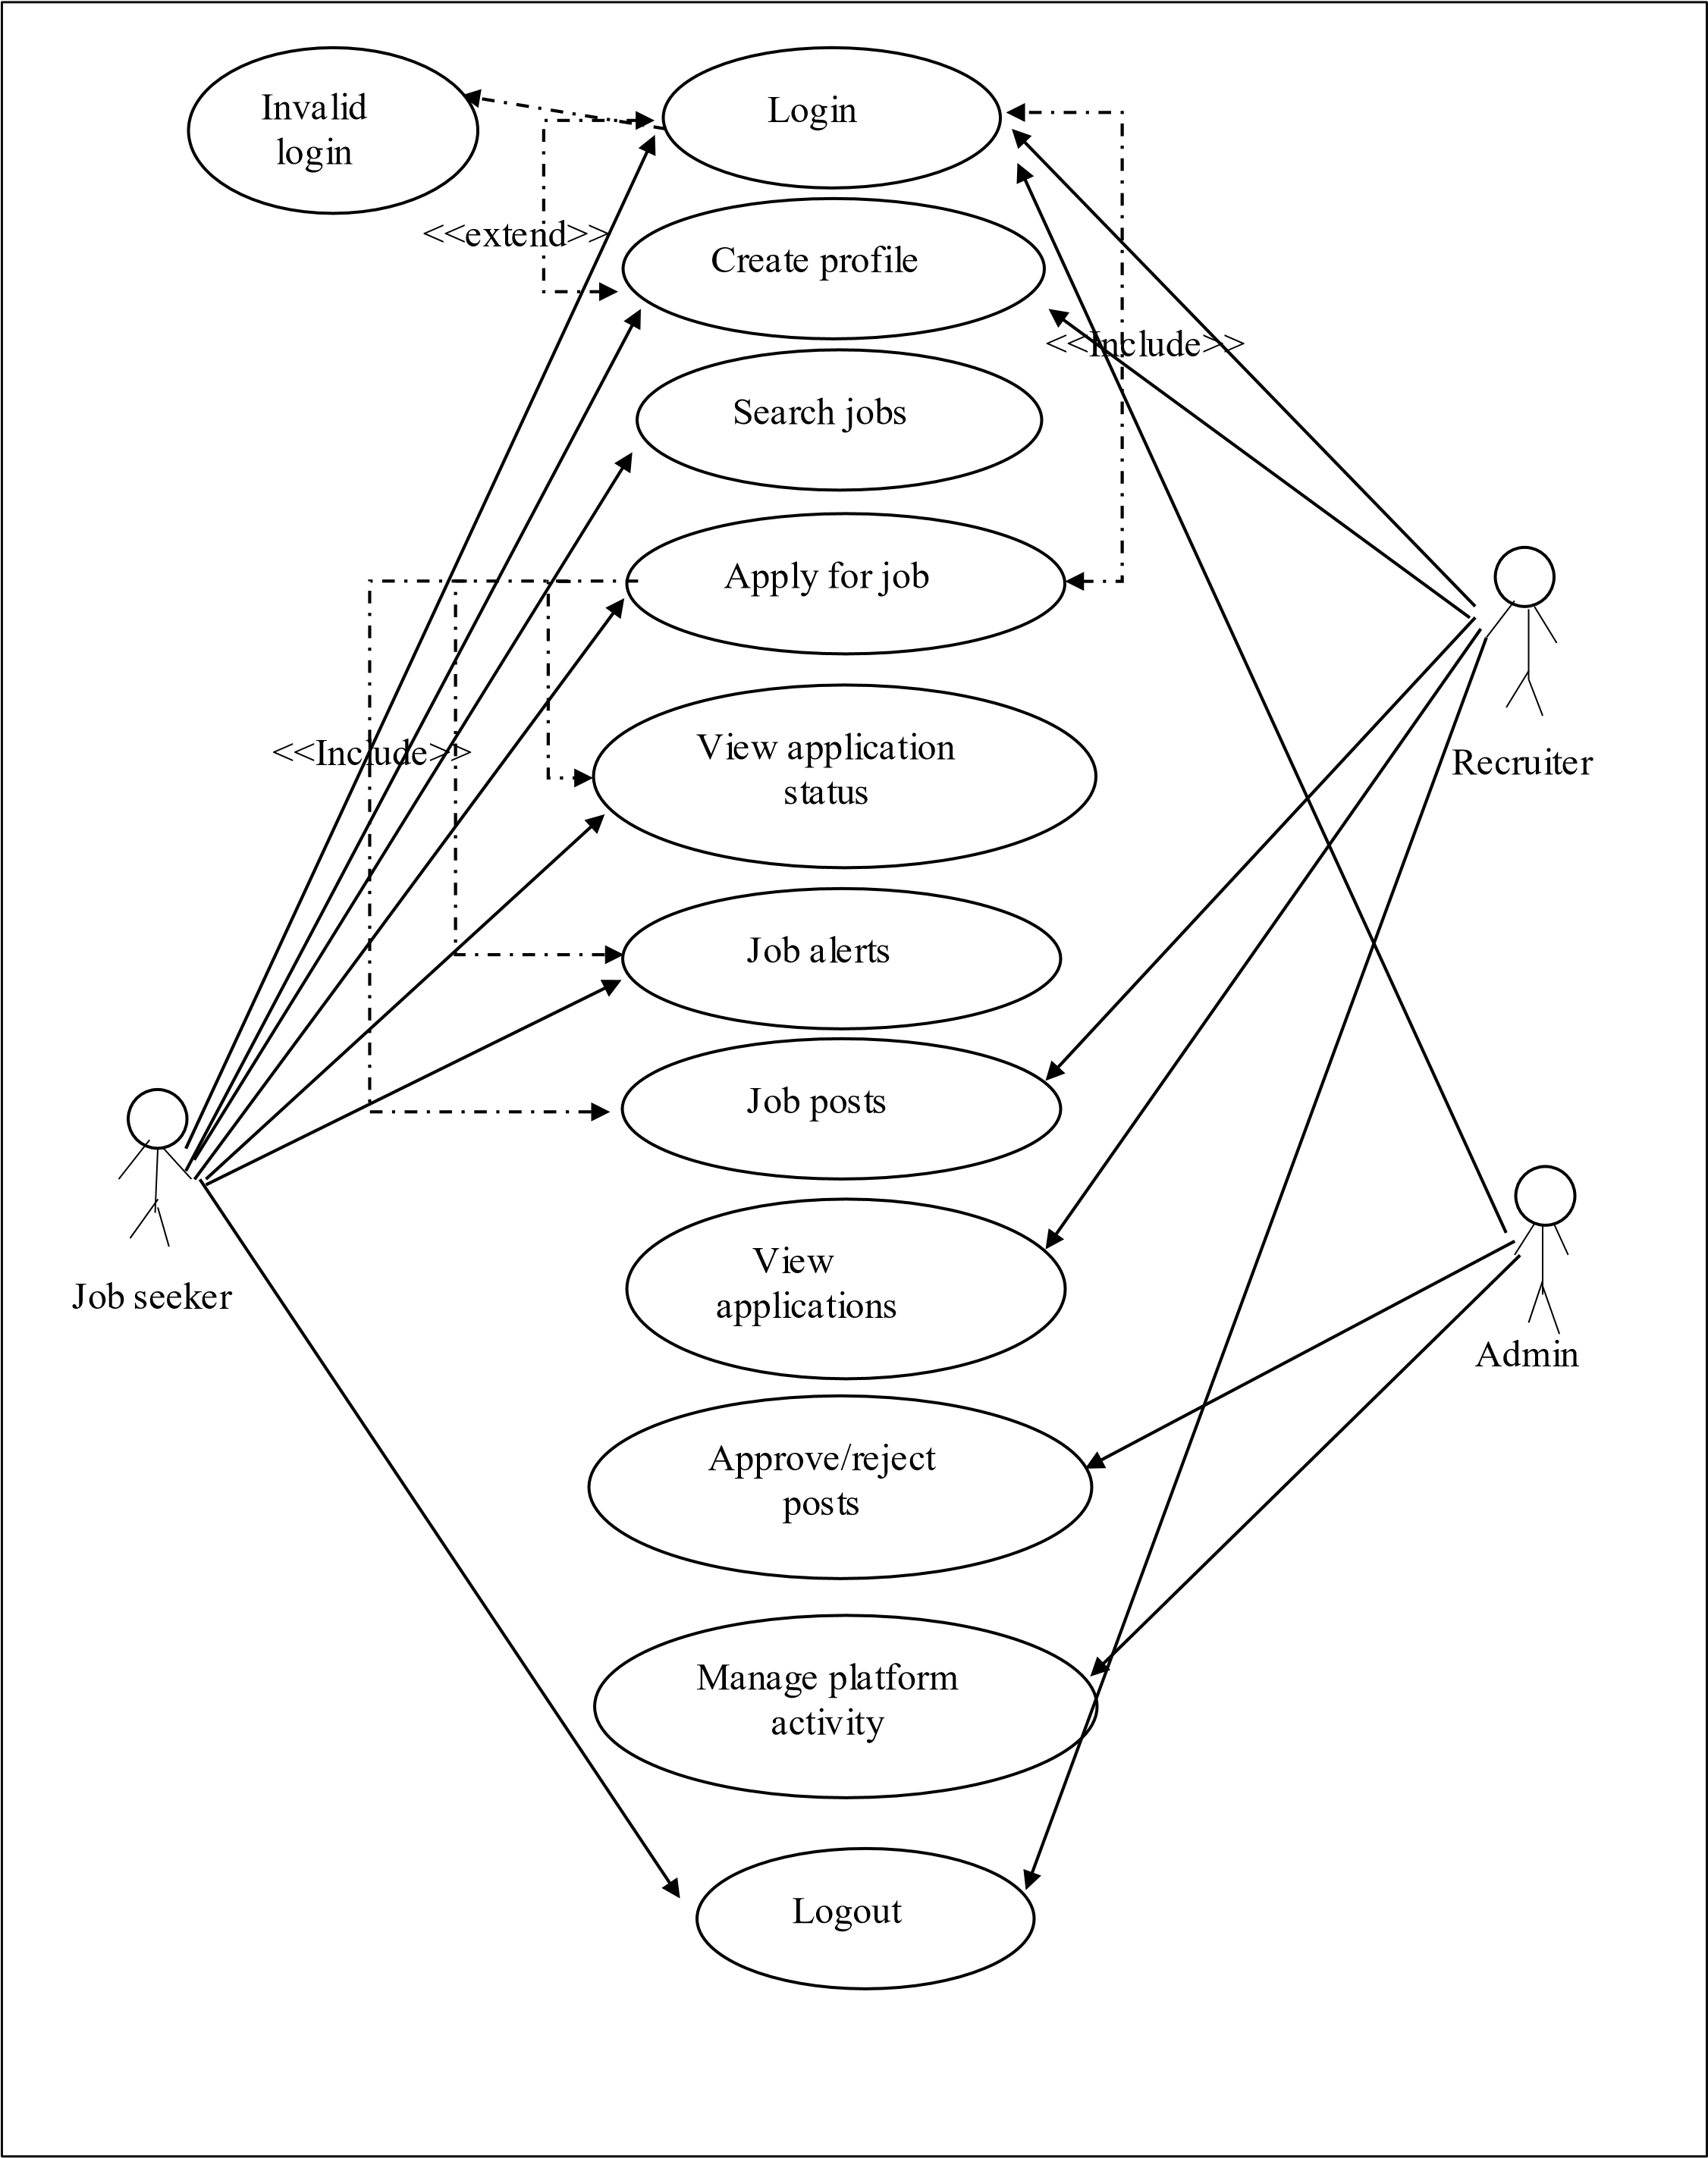
3.13Use Case diagram of “Laravel based job portal web app”

3.2 Use case description
Use case diagrams to identify the interactions between the system and its actors. The use cases and actors in use-case diagrams describe what the system does and how the actors use it, but not how the system operates internally.
3.2.1 Actor:
Actors are defined as people, software, or some system that interacts with the web application. In this web application actors are
- Admin
- Recruiter
- Job seeker
3.2.2 Use case:
Function or operation write the name inside it. In this web application, some use cases are
- Profile management
- Apply for job
- Search for job
- Review application
- Job posts
- Approve or reject posts
- Manage platform activity
3.2.3 Link:
Link “-” link, connect, or interact with the use cases.
- The job seeker searches or browses available jobs.
- The job seeker clicks on a job listing to view the full job details.
- On the job details page, an "Apply Now" button or external link is displayed.
- The job seeker clicks the "Apply via Company Site" link.
3.2.4 Relationship:
It has three types.
  - Generalization:
Relationship between parent and child use cases.

  - <<Include>>
It is an implicit function that has mandatory steps carried out to accomplish a function.

1 View application status (Job Seeker):
The "View application status" use case includes the "Login" use case. To check the status of their applications, a job seeker must first be logged into their account.

- Job alerts (Job Seeker):
The "Job alerts" use case includes the "Login" use case. To manage or receive job alerts, the job seeker needs to be logged in.

- Job posts (Recruiter):
The "Job posts" use case includes the "Login" use case. Recruiters must log in to the system before they can create and manage job postings.

iii. <<Extend>>
It is an explicit function, steps taken by you as per the choice of optional function.
The "Invalid login" use case is not always executed when a job seeker tries to "Login." It only happens as an alternative flow when the login attempt fails. The "Login" use case can complete successfully without the "Invalid login" use case ever being triggered.

3.2.5 System:
The boundary box represents by a rectangle shape.

3.2.6 Actor:
Actors have two types.
- Primary Actors:
Initiate the use of the system. It has a position on the left side of the system. E.g. job seeker.

- Secondary Actors:
More reactionary responses to the primary actor. It has a position on the right side of the system.
E.g. Admin

ACTIVITY DIAGRAM:

Use case “log-in” Activity diagram

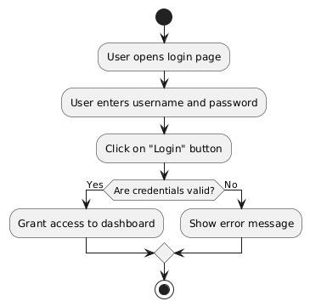

Use case “Create profile” Activity diagram

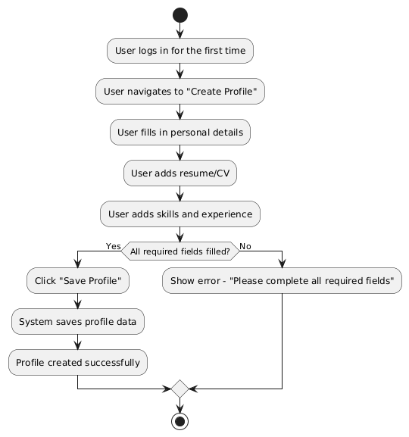

Use case “search for job” Activity diagram

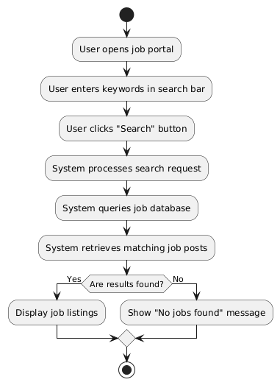

Use case “view application status” Activity diagram

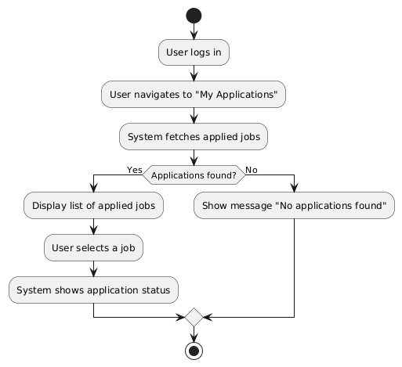

Use case “manage platform activity” Activity diagram

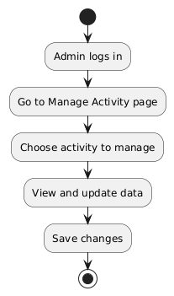

Use case “Approve / reject posts” Activity diagram

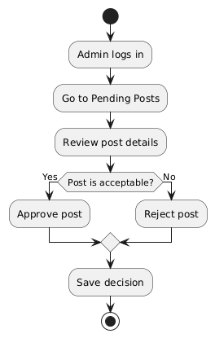

Use case “Approve / reject posts” Activity diagram

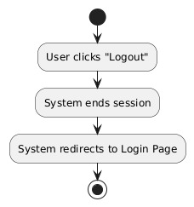

4:References
    - Google
    - Chatgpt

